We have a .NET executable file. dnSpy for sure 🙂

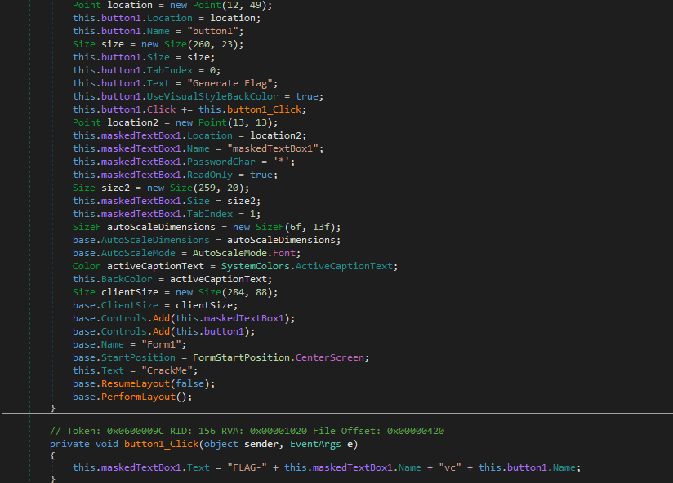

see through star already huh?

It just concates some strings to generate the flag

‘FLAG’ + this.maskedTextBox1.Name + ‘vc’ + this.button1.Name

We can easily find maskedTextBox1.Name and button1.Name in the code above